**A Comparative Analysis of Hourly Environmental Conscious Energy Production Strategies in Europe: Case Studies of Germany, France, Italy, and Spain**

**Abstract**:

This research paper investigates the environmentally conscious strategies employed in the production of energy on an hourly basis in four prominent European countries: Germany, France, Italy, and Spain. The study analyses the various approaches adopted by these nations to achieve sustainable and eco-friendly energy production. The research focuses on the utilization of renewable energy sources over the years to minimize environmental impact. By examining the Sources of energy production, we aim to identify patterns, trends, and lessons that can contribute to the development of effective and sustainable energy sources.

**Introduction**:

Background:

The increasing global concern over climate change and environmental sustainability has prompted nations to reassess their energy production strategies. Europe, as a leading promotor of green initiatives, has been at the forefront of adopting environmentally conscious practices. This paper explores the specific energy aggregation sources employed by Germany, France, Italy, and Spain to produce energy in an eco-friendly manner.

Objectives:

- To analyse the hourly patterns of energy production from various sources in Germany, France, Italy, and Spain.

- To evaluate the adoption of renewable energy sources in the energy mix.

- To identify successful strategies and lessons that can be applied globally.

Methodology:

Data Collection:

Hourly energy production data for each country was obtained from [Kaggle](https://www.kaggle.com/datasets/mehmetnuryildirim/hourly-power-generation-of-europe), the data is retrieved from ENTSO-E (European Network of Transmission System Operators) Transparency Platform. The data covers specific period, from January 2015 to September 2022, capture seasonal variations and changes in energy demand.

Statistical methods, graphs, and visualisation tools were employed to examine the hourly trends in energy production.

A dataset of 475193 rows of data on power generated each hour was used to prepare the analysis from 4 countries.

The data was processed and cleaned and sampled in Python and Visualised and Analysed in Power BI tool, Tableau prep builder and Excel

**Analysis:**

**Germany**:

Non-Renewable Energy

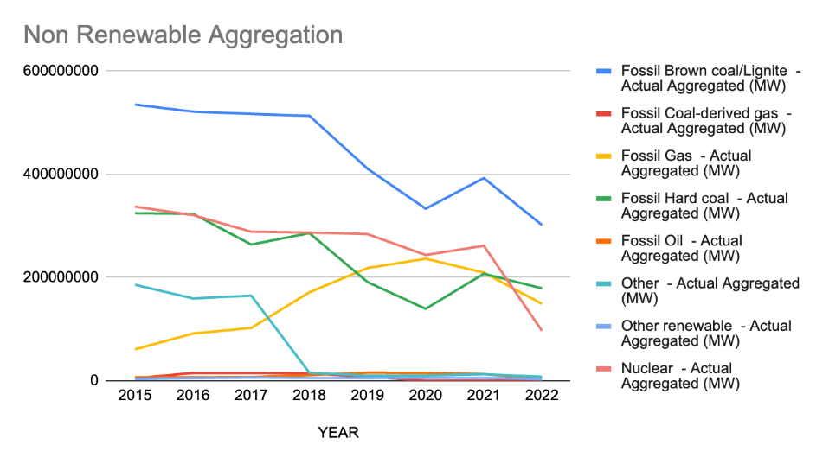

Fossil coal and hard coal experienced a substantial decline from 60 million MW to half the value over the seven-year period.

Fossil gas power aggregation increased from 5 million MW to 25 million MW, highlighting a shift towards cleaner fossil fuel options.

Nuclear power witnessed a decline during the analysed period, emphasizing the need for alternative energy sources.

Renewable Energy: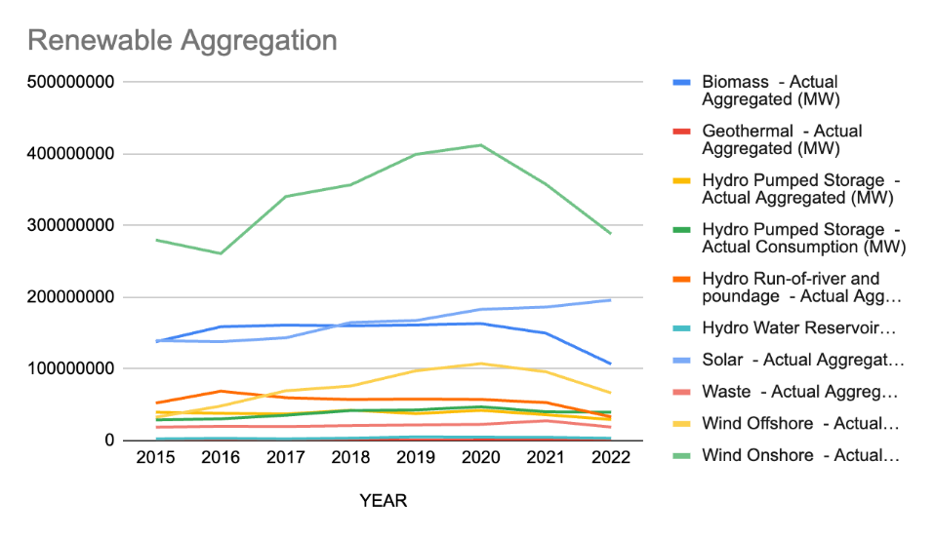

Wind emerged as a major contributor in the renewable energy sector, reaching 30 million MW, followed by solar at 20 million MW.

Hydro, geothermal, and other renewable sources remained marginal, indicating areas for potential exploration and improvement.

France:

Non-Renewable

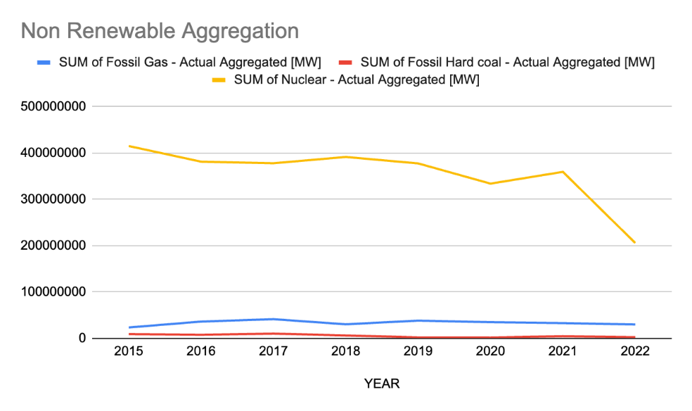

Fossil hard coal peaked in 2017 at 10 million MW and experienced a consistent reduction over the years.

Fossil gas energy aggregation was 40 million MW in 2017, steadily decreasing from 2019 onwards.

Nuclear power, while high at 400 million MW in 2015, showed a slow reduction to approximately 350 million MW in 2020.

Renewable Energy:

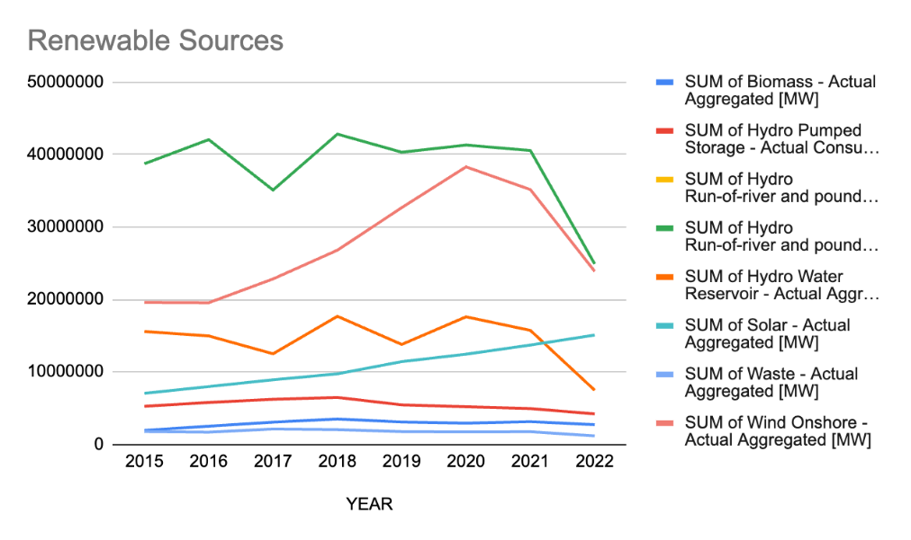

Renewable sources, especially from running river water, remained constant at 40 million MW until 2022.

Solar and onshore wind energy exhibited a doubling aggregation from 2015 to 2022.

Italy:

Non-Renewable

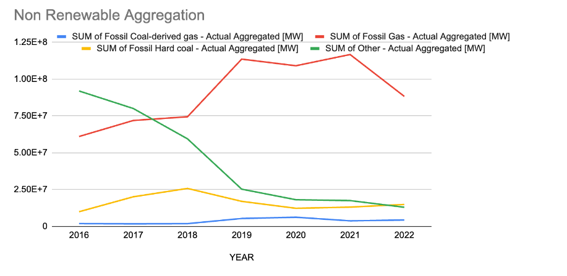Fossil gas usage increased from 45 million MW to 80 million MW, indicating a growing reliance on this fossil fuel.

Coal dropped from 50 million MW to 10 million MW, aligning with the trend of reducing reliance on traditional fossil fuels.

Nuclear power remained steady at approximately 55 million MW, highlighting its consistent contribution to the energy mix.

Renewable Energy:

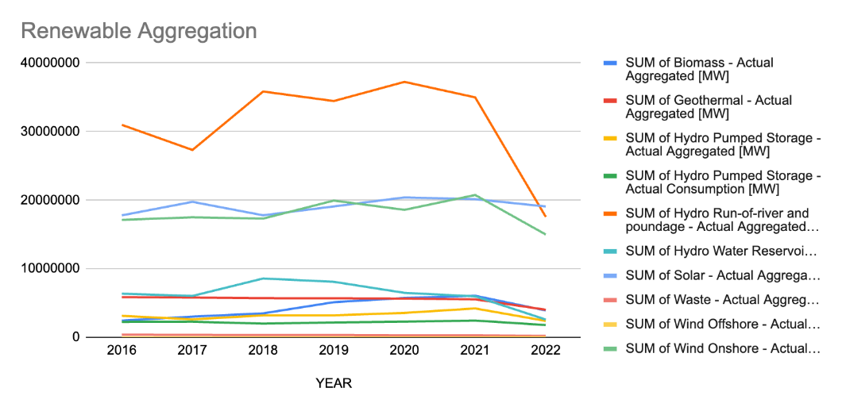

Onshore wind emerged as the highest contributor with 50 million MW, showing a consistent increase over the years.

Other renewable sources had the lowest contribution, signalling potential areas for improvement.

**Spain:**

Non-Renewable Energy

Fossil gas aggregation increased from 35 million MW in 2015 to 75 million MW in 2022, indicating a significant reliance on this fossil fuel.

Fossil hard coal fell from 45 million MW to less than 10 million MW in 2022, displaying a successful reduction strategy.

Nuclear aggregation remained constant at 55 million MW throughout the analysed period.

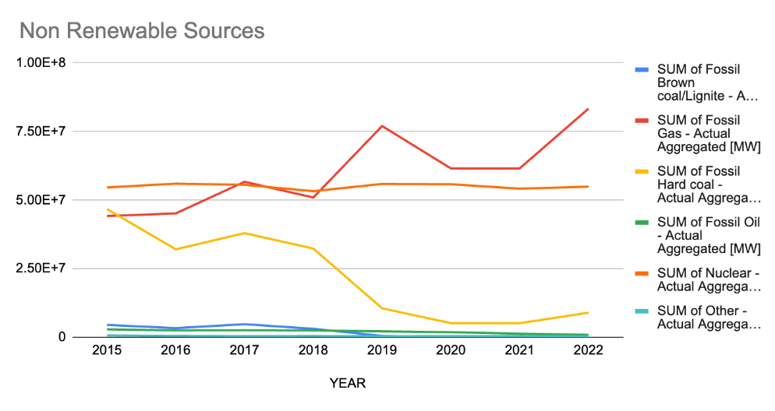

Renewable Energy:

Onshore wind aggregation increased from 45 million MW to 60 million MW in 2021, highlighting a positive trend.

Hydro power from running water remained below 10 million MW, indicating a need for improvements in this sector.

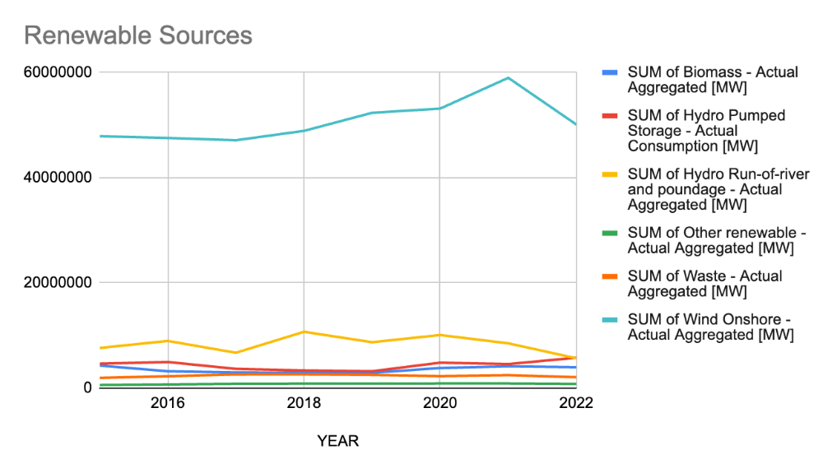

**Policy Recommendations**

**Government Initiatives:**

Implement Renewable Energy Incentives:

* Encourage private and public investment in sustainable energy sources by offering financial incentives.
* Stimulate growth in the renewable energy sector through supportive policies and subsidies.

**Establish Transparent Regulations:**

* Develop clear and accountable regulations for energy production and consumption.
* Promote sustainability and ensure adherence to environmentally friendly practices within the energy sector.

**Invest in Research and Development (R&D):**

* Allocate resources to research and development initiatives.
* Foster the creation of new technologies to enhance energy efficiency and reduce carbon emissions.

**Energy Regulators:**

**Grid Modernization:**

* Promote modernization of the energy grid for better integration of renewable energy sources.
* Ensure a stable and reliable energy supply through advanced grid technologies.

**Encourage Collaboration:**

* Facilitate collaboration and knowledge sharing among energy stakeholders.
* Foster an environment of innovation and the adoption of best practices within the energy industry.

**Industry Stakeholders:**

**Invest in Renewable Energy Infrastructure:**

* Allocate funds for the development and implementation of renewable energy infrastructure.
* Support the transition to a low-carbon economy through strategic investments in clean energy projects.

**Adopt Sustainable Business Practices:**

* Incorporate sustainable business practices to reduce the environmental impact of operations.
* Promote energy efficiency within their facilities to contribute to overall sustainability goals.

**Conclusion:**

To accelerate the transition to renewable energy in France, prioritize further reductions in fossil gas and nuclear power, while expanding solar and onshore wind capacities. In Spain, capitalize on the declining fossil hard coal by investing in onshore wind and hydro power. Italy should continue boosting onshore wind and explore diverse renewable sources. Germany should focus on sustaining the decline in fossil coal, increasing wind and solar capacities, and exploring untapped potential in hydro, geothermal, and other renewables. Collaborative efforts among these nations can facilitate knowledge exchange and enhance the collective move toward a sustainable energy future.